## 

# Admob mediation Pegasi sdk Doc

1. If you want to integrate Banner Ad , Please set CMCustomAdProvide.java and CMAdCustomEventBanner.java on the specified path;

2、Copy.aar file to libs of project,add code to Gradle script.Open your project’s build.gradle file and add the below lines

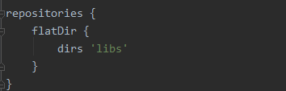

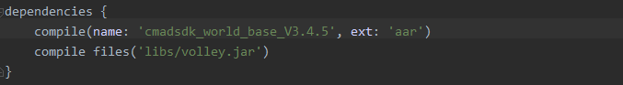

3、Please initialize PEGASI SDK and we highly recommend you call the onCreate method in Application class



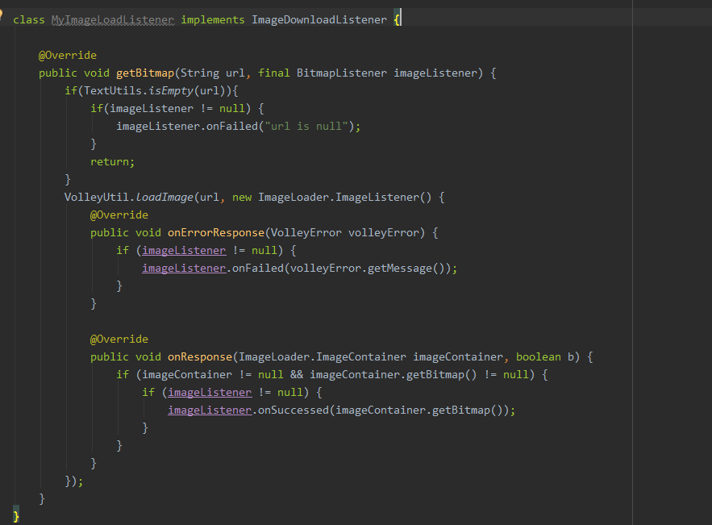

4、Add confusion script

-keep class 包名 . CMAdCustomEventBanner{*;}

or

-keep class 包名 . CMAdCustomEventInterstitial{*;}